Proposal

for

SATELLITE BASED TAXI TRACKING & FLEET MANAGEMENT SYSTEM


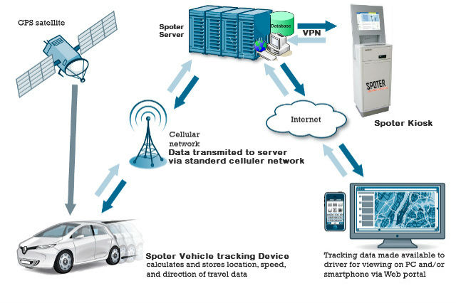

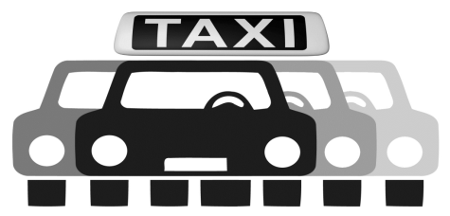

One area where vehicle tracking software has proved extremely beneficial in recent years is in helping with taxi fleet management, whether in small towns or big cities. The latest technology is easy to use, allowing dispatchers and taxi fleet owners to keep tabs on their vehicles and manage them more effectively. Knowing where your drivers are at certain moment’s means that you can work to reduce the time it takes to get to customers and cut down on fuel costs and transportation time.
SPOTER Solutions for Taxi dispatch is designed to keep track of vehicles, where they are at any point in time, logging jobs and directing drivers as well as a host of other useful tools such as live and historic reporting. Depending on road and traffic conditions, owners and fleet managers can keep track of driver behavior such as hard acceleration, braking and engine idling that could be used to improve performance and reduce the possibility of accidents and a more comfortable ride for customers.
Advantages of vehicle tracking technology include:
- Theft Recovery: If a taxi cab driver is ever held at gun point or has his cab stolen the data from the tracking system will quickly lead law enforcement to the location of the stolen cab. Recovering the stolen cab and catching the criminal(s) is much easier when a vehicle is equipped with a GPS tracking device.
- Traffic Jam Avoidance: When a vehicle is installed with a GPS tracking system people monitoring the GPS tracker from a control room can alert cab drivers if they are about to enter an area clogged with traffic. The GPS tracking device allows the operator to easily re-route the cab driver, which saves you money!
- Historical Data: GPS tracking devices have the technological ability to store information for extended periods of time, therefore, if a cab company ever wanted to audit a driver's routes driven for the week they could easily do so by reviewing the historical records of travels by accessing the recorded GPS tracking data.
Spoter Tracking Solution is happily used for fleet management are nothing new among businesses with large numbers of mobile resources. Everyday businesses across the globe contact Tracking System Direct to inquire about Spoter - vehicle tracking products for their monitoring needs.

Why GPS Tracking:
Vehicle tracking systems are commonly used by fleet operators for fleet management functions such as fleet tracking, routing, dispatching, on-board information and security. for example by sending an automatic alert to a phone or email if an alarm is triggered or the vehicle is moved without authorization, or when it leaves or enters a geofence.
Other scenarios in which this technology is employed include:

HIGHER CUSTOMER RETENTION
Retaining current customers is a high priority. In several cases, the detailed reports of SPOTER - Vehicle Tracking System provided led to higher customer retention numbers. Customers like to see proof that service was completed on time, and by providing that proof, you keep your customers and your commission.

PROTECTION AGAINST FALSE CLAIMS
Spoter provides irrefutable data showing when and where each vehicle has traveled, providing protection against false accident claims and reports of late arrivals at scheduled appointments.

SERVICE TIME TRACKING
Spoter provides electronic verification of service time, providing drivers with "Back Up" in case of customer challenges.

HANDS-FREE MILEAGE LOG
Spoter provides an accurate, hands-free mileage log, saving valuable time.

VEHICLE TAKE HOME POLICIES
With evening and weekend use can be monitored, few of our clients are now able to allow employees to use fleet vehicles after-hours. This saves many employees, and the company valuable, time and fuel.

INCREASED COMPANY PROFITS
Increased savings and company profits translate to better results, better maintenance programs to minimize on-the-road problems, replacement of aging equipment, etc.

NEW INCENTIVES
Spoter allows you to measure performance efficiently; you can create new incentives based solely on productivity. It is amazing to see the changes in performance once drivers take the competitive spirit to heart. Before you know it, they will be helping you find new ways of bringing in revenue.

INCREASED DRIVER SAFETY
Financial gain is not the most important benefit for drivers. The incidence and severity of crashes and driver fatalities increase disproportionately with speed. Because maximum speed is automatically recorded, driver safety can be easily monitored.

IMPROVED DRIVER MORALE
Because with Spoter driver accountability is not an issue any longer, you do not run the risk of getting caught up in "Gotcha" Management. On the contrary, you now have a tool to catch your drivers doing something good so you can enhance their performance and self-esteem. Good drivers are usually reluctant to report their inefficient counterparts. In many cases, good employees wind up carrying the burden of the "Slackers". This has an adverse impact on morale. You now have the tool to deal with unproductive drivers.
SPOTER

Here are some essentials, SPOTER – Vehicle Tracking Systems features to consider which will help you to choose Spoter as the right product that fits your needs and budget.
REAL TIME TRACKING
Spoter Tracking devices are enabled with real-time monitoring. Location of the vehicles is tracked on the map as it moves from point to point. The GPS location of your vehicle is displayed on a map along with vehicle speed if the vehicle is moving. The current state of the vehicle like moving, parked since or idle is shown using map markers. Multiple vehicles can be grouped and managed simultaneously using simple to use interface.
TRIP HISTORY.
You can track all the trips made by the vehicle graphically on the map. Information such as kilometers traveled, stoppages, idling, engine time and average speed is displayed. Over speeding and overdrive stretches are highlighted on the map. Spoter systems also come with an option to replay the entire trip. This feature brings in value for both business owners and chauffeur driven car owners.
ALERTS.
Using, Spoter vehicle tracking system; features like over speeding alert, start of day alert, route deviation alert and excessive stoppage alert, one can analyze driver behavior and optimize fuel usage and optimizing workforce. Depending on your need there are several alerts that can be configured: Idling Alert, Stoppage Alert, Tampering Alert, Over-speeding Alert etc.
ANYTIME ANYWHERE ACCESS.
Spoter connects you to the world where any and every information is available at your fingertips, it is imperative invest in a vehicle tracking system that is accessible on web and on smart phone.
GEO FENCING.
Geo-fencing takes alert customization to the next level. You can create geographical boundaries called Geo fences on the map around a landmark. An alert is sent out every time the vehicle enters or exits the Geo fence. This opens up immense possibilities in different ways of using the monitoring information that can translate into increased operational efficiency, workforce optimization and elevated security and safety levels for the user.
HISTORICAL REPORTS AND DASHBOARD SUMMARY.
For businesses where medium to large fleet s involved, access to location and event reports provides high ROI. Fleet managers can track and analyze information on their vehicles up to 30 days in the past and make informed decisions that could positively impact their business. Spoter Solution comes with enterprise dashboard has a comprehensive set of graphical reports. This gives you an overall view of the metrics that matter for your business performance. There are reports for total distance traveled, idling time, over speeding, stoppages and utilization. You can see the metrics for different groups of vehicles and for different time periods.
EASY TO USE, USER FRIENDLY INTERFACE.
Spoter is simple and intuitive user interface providing powerful features like group-wise access without the need for multiple accounts, bird’s eye view of entire fleet and the ability to report historical and real-time data. A simple yet well-developed intuitive user interface allows easy access to the right information to make informed decisions.
ACCESS CONTROL AND USER MANAGEMENT.
User management and Access control is an important vehicle tracking system feature for business owners. With Spoter you can perform vehicle tracking for a group of vehicles and also view the report information for a group as a whole.
ANALYTIC.
Spoter tracking devices have innovative enterprise solution designed to harness the power of location based services and integrating it with cloud computing to make actionable fleet data available at the operator’s fingertips to ensure predictive performance of the fleet.

Commercial Pricing Proposal – Vehicle Tracking Solution
SL NO. | KEY FEATURES | SILVER  7000 | BRONZE 8000 | GOLD  9500
1 | Track your vehicle in real time. | Yes | Yes | Yes
2 | Get reports of each vehicle's daily activities. | Yes | Yes | Yes
3 | Real-time monitoring and on board data storage. | Yes | Yes | Yes
4 | Online tracking with motion directions. | Yes | Yes | Yes
5 | Geo-fencing/location /power off/ Over speed alert. | Yes | Yes | Yes
6 | Send sms to get current location of vehicle on mobile. | Yes | Yes | Yes
7 | Shortest path finder. | Yes | Yes | Yes
8 | Multi-Geo fence | Yes | Yes | Yes
9 | 1yr. Server, Storage, data Charge Paid | Yes | Yes | Yes
10 | Detailed trip report. | Yes | Yes | Yes
11 | ACC ignition detection, vehicle status notification | Yes | Yes | Yes
12 | External SOS button, used in immergence case use | No | Yes | Yes
13 | Build-in back up battery,  support illegal main power cut-off alarms | Yes | Yes | Yes
14 | External Relay, used to cut off engine power or oil remotely | Yes | Yes | Yes
15 | External Microphone, used in voice monitoring case | No | Yes | Yes
16 | Door open /shock alert | No | No | Yes
17 | Idling vehicle report. Hijack recovery system through engine shutdown. | Yes | Yes | Yes
18 | Turn off vehicle remotely during theft. Speeding notifications. | Yes | Yes | Yes
19 | Commands from your cell phone. Mileage statistics Door Locking | No | No | Yes
20 | USB configuration (option) | Yes | Yes | Yes
21 | SOS emergency alarm. | No | Yes | Yes
22 | Optional Fuel Censor compatible | No | No | Yes
23 | Internal Antenna | Yes | Yes | No
24 | Inbuilt Geo Storage by SD card | No | No | Yes
25 | External GPS Antenna and GSM Antenna | No | No | Yes
26 | RFID Remote Controller | No | No | Yes
27 | Streaming technology Support | No | No | No
28 | 1 Yr. warrantee | Yes | Yes | Yes
29 | Works on 9V to 24V | Yes | Yes | Yes
30 | Reset Configuration | Yes | Yes | Yes
31. | Yearly Renewal After First year | 3000/- | 3600/- | 3600/-
32. | Extended Warrantee for One Year | 2000/- | 2000/- | 2000/-

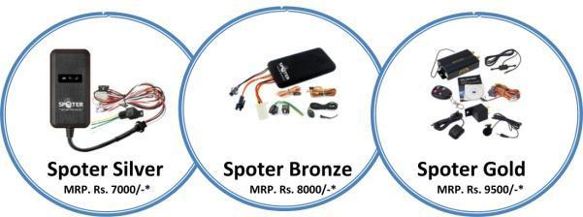
- Taxes applicable extra as applicable.

Terms & Conditions:

Warranty
1 year repair/replacement standard limited warranty on the Tracking Device.
Annual Maintenance Cost Rs. 2000/-
To extend the comprehensive warranty you will need to cover them under an AMC.
AMC will cover:
- Unit replacement in case of damage one time maximum for four times.
- 4 preventive service calls per unit yearly
- 4 trouble-shooting calls per unit yearly
Terms and Liabilities
A. Payment: 100% advance against purchase order.
B. Delivery: Delivery within 2-3 Weeks of receipt of purchase order and advance payment.
Carry – In Warranty
Spoter warrants that in normal usage and with proper maintenance, its product (Vehicle Tracking Unit) will conform to their specification for a period of 12 months from the date of purchase by the customer, subject to the conditions, limitations and procedure listed below. Any product, which proves to be defective in normal usage during that 12 months period, will be repaired at Spoter or replace by Spoter. Warranty does not cover any battery, pad, Antennas & cables.

Limitations
Spoter shall be limited to the repair or replacement of any parts of the product, which are defective in materials.
Spoter shall not be liable in any way for Product failure, or any resulting loss or damage which arises from:

- Use of product in an application for which it was not designed or intended.
- Corrosion, degradation or wear and tear.
- Failure to service or maintain the product in accordance with Spoter recommendations.
- Faulty or deficient installation of the product.
- Any modification of alteration of the product.
- Conditions that exceed the products performance specifications or safe working loads.
- This warranty does not cover any incidental costs incurred for the investigation, removal, carriage, transport or installation of product.
- Service by anyone other than authorized Spoter representatives shall be taken as warranty void unless it accords with Spoter guidelines and standards of workmanship.

Liability
Spoter shall not be responsible for
- Any loss of anticipated turnover or profit or indirect, consequential or economic loss.
- Damages, costs or expenses payable to any third party.
- Death or personal injury.
- Any loss of warranty of vehicle due to installation of device.

Procedure
- Both warranty and non-warranty repairs can only be performed at Spoter.
- The customer shall send the goods together with an order for warranty or non-warranty repair to the Spoter service office. The order shall be delivered in writing by mail or electronic mail.
- The order must contain a detailed description of the defect.
- Both warranty and Non-warranty repairs shall be carried out by Spoter in 25-30 working days from the receipt of order.
- In case of warranty repair, the customer shall be responsible for transport of goods to service office and transport of goods back to the customer. If it is found that the repair is not subject to warranty, all costs of repairs will be borne by the customer.

Service Level Details
- In case of any manufacturing defect in the Tracking Unit or need for any trouble-shooting in the Tracking software, the support team will respond to addressed problem within 6 hours provided the vehicle is made available for check at mutually agreed location.
- For the location other than mutually agreed location, the service engineer will assess the cause of problem and will provide the time and assistance to repair, on case basis. The response of support service will be in addition to the travel time to provide the response.

Validity of Proposal
The proposal for Vehicle Tracking Solution will be valid for duration of 7 days from the date of submission.

For demo: login onto: www.surat.spoter.co.in - Under ‘Tracking - Server 1’.
USERNAME: demo
PASSWORD: demo

Thanking You…
We look forward to hearing from you.

Contact Person – Mr. KARUNESHKUMAR ZAVERI.
Designation – Distributor.
Telephone - +91 99981 97025
Email – karunesh.surat@spoter.co.in
Website - www.surat.spoter.co.in

